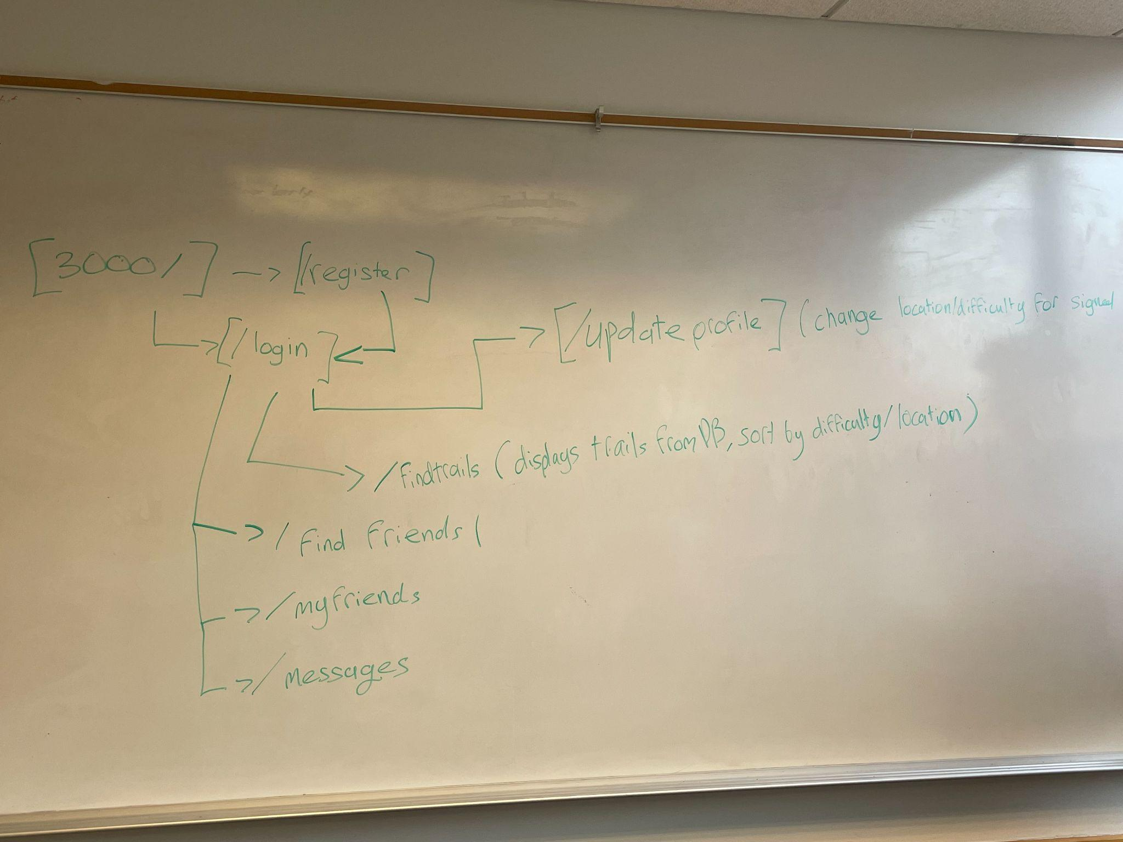

/myProfile

* Photo
* Bio
* Max Difficulty - Skill level
* Trails climbed
  + List of all trails climbed
* City
* Button -> /editProfile\

/editProfile

* Same as /myProfile
* All buttons as optional text inputs.

/findTrails

* Basic trail display functionality
  + Display list of trails -> /trail#
  + Individual user sorting: by difficulty
  + Button -> /addTrail

/findFriends

Basic friend button list

Friend Button: Name, Skill level, location categories

Button in each user of list to Add Friend

Each button -> /theirProfile

/theirProfile

Photo

* Bio
* Button - Add Friend
* Max Difficulty - Skill level
* Trails climbed
  + List of all trails climbed
* Button -> Add Friend
* City:

/logout

Throws back to login/page

